Test: Unit 2
Reactions
Name:____________________
Instructions:
You will have the entire period to complete the test (75 minutes)
The test is made up of 4 sections:
Section A – Multiple Choice
Section B – Matching
Section C – short answers
Section D – Equations
Please follow all the instructions
Please read all questions carefully
A mark breakdown of the test can be found after these instructions
Good Luck!

Mark Summary
Section | Knowledge  /Understanding | Thinking | Application | Communication | TOTAL
A | 10 | / | / | / | 10
B | 10 | / | / | / | 10
C | / | / | 4 | 2 | 6
D | / | 19 | / | 6 | 25
Sub‐Total | / 20 | / 19 | / 4 | / 8 | / 51

Comments:

Section A – Multiple Choice (10 Marks – Knowledge/Understanding)
Choose the best answer for each of the following.
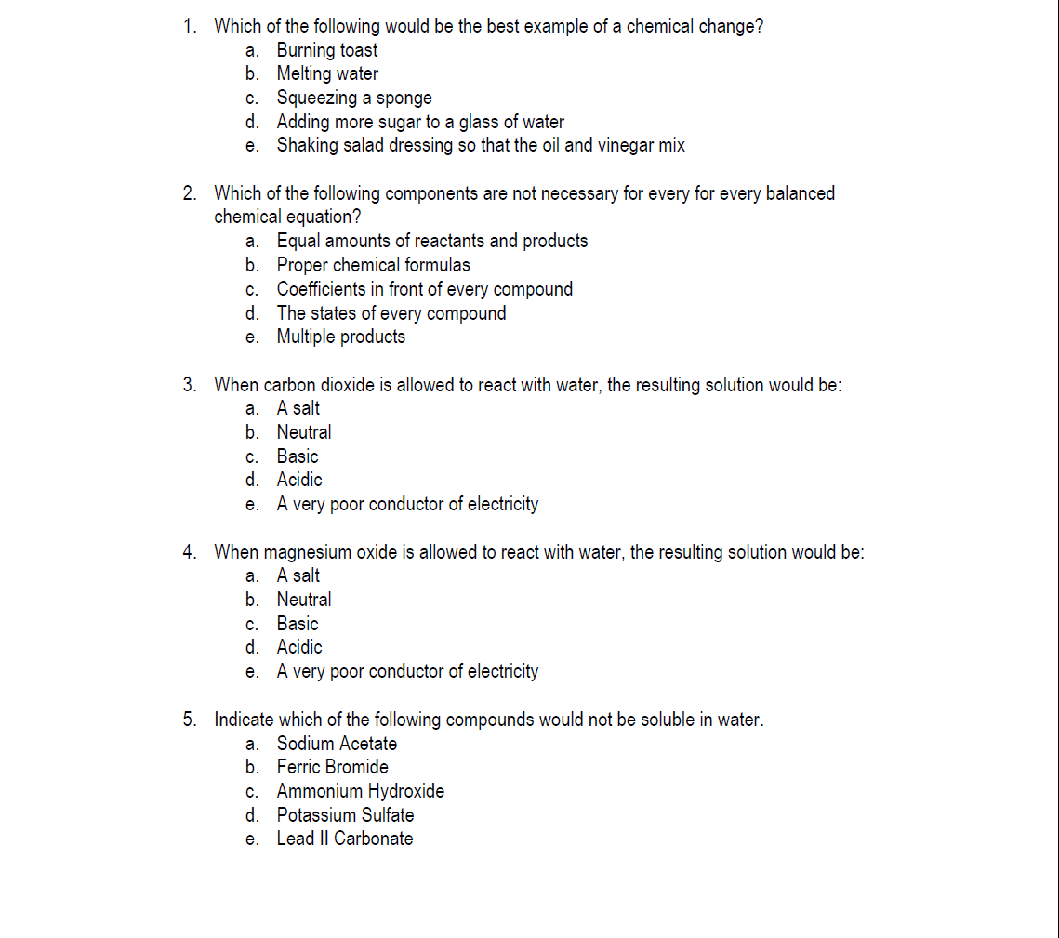
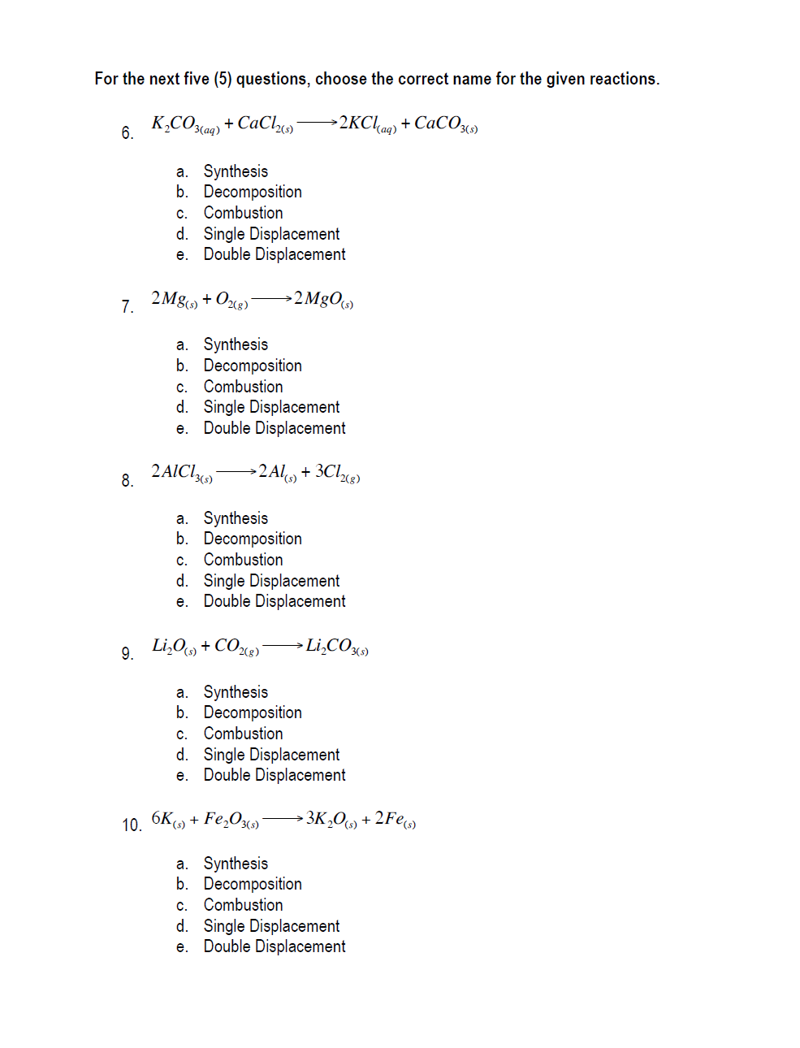

Section B – Matching (10 Marks – K/U)
Match the term on the left with the appropriate definition on the right.
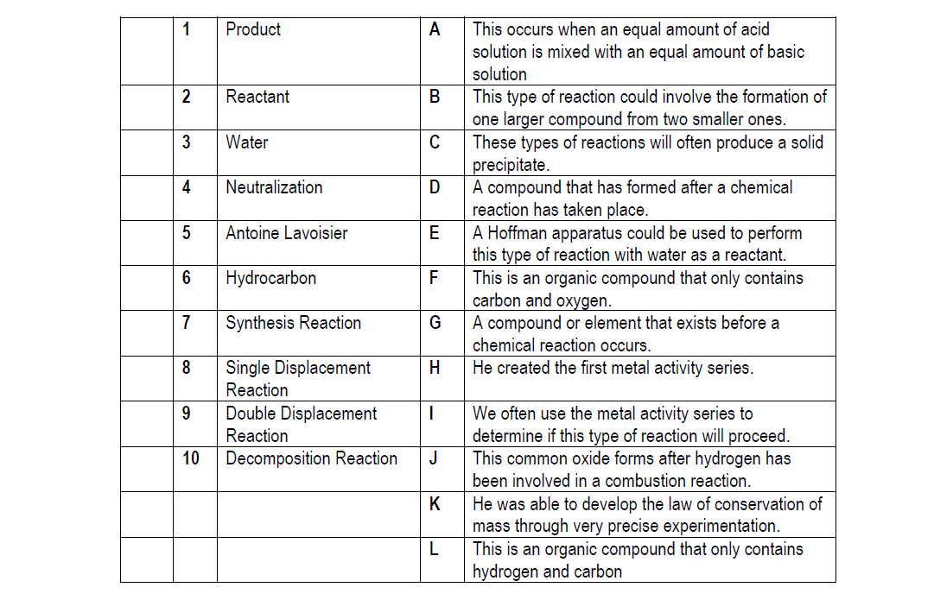

Section C – Short Answer (6 Marks)
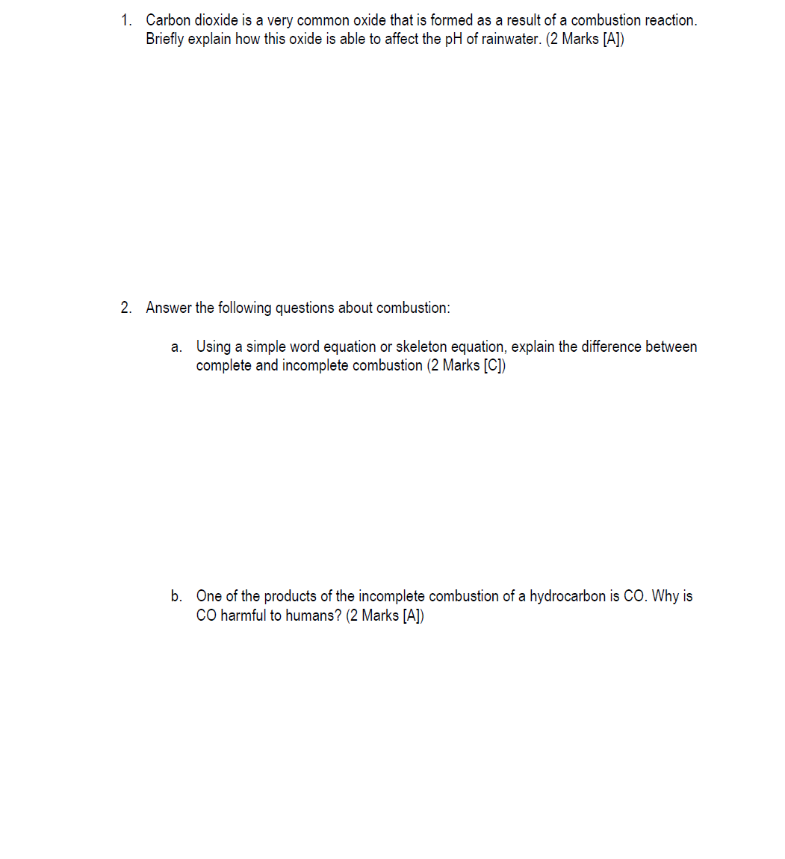

Section D – Working with Chemical Equations (25 Marks)
